Asset Management Funding | 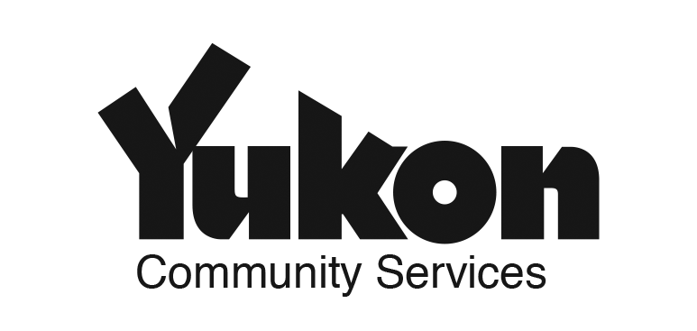
2016 APPLICATION FORM
Completed application forms and required attachments are due no later than February 1, 2016. Please type directly in this form or print and complete. Attach additional pages if required.

Maximum amount that can be applied for through this fund: $40,000. All funds must be spent by December 31, 2016 and accounted for by January 31, 2017.

Questions? Contact Community Affairs at (867) 667-8334 or email chris.madden@gov.yk.ca.
Applicant Information
Government Name: | Complete Mailing Address:
Contact Person: | Position:
Phone: | E-mail:

- PROJECT INFORMATION

Project title:

Proposed project start and end dates: Start: End:

Total Project Budget:
Total Amount Requested through Asset Management Funding:
- Current status of asset management expertise (based on self-assessment with AssetSMART tool). Please select your current status and provide a description of current level of asset management expertise.
Beginner Intermediate Advanced

- PROPOSED ACTIVITIES. Please describe the specific activities you plan to undertake, i.e. baseline assessment, asset management policy, asset management plan, training, etc.

- Intended outcomes, deliverables, and impacts on local government. What will your project achieve? What will be the specific deliverables? List any policies, practices, plans or local government documents that will be developed or amended as a result of your project.

- ADDITIONAL comments - Please use this space to add any additional comments.

- REQUIRED ATTACHMENTS - Please submit the following with your application:
Letter of support from Council indicating your government’s support for asset management implementation and commitment to participate in the Yukon Asset Management Community of Practice.
A copy of your organization’s AssetSMART self-assessment.
- SIGNATURE – Applications are required to be signed by the local government applicant.
_________________________ Signature | _________________________  Name and Title

(FOR YG USE ONLY)

Approved by: _________________________________________
Date: _________________________________________

Please mail or fax your funding application and supporting documents to:
Community Affairs C-11
Government of Yukon
Box 2703
Whitehorse, YT Y1A 2C6

Fax: 867-393-6397

